Jobs:



Jobs are to complete curtain tasks in Kubernetes cluster.

Two types of jobs:

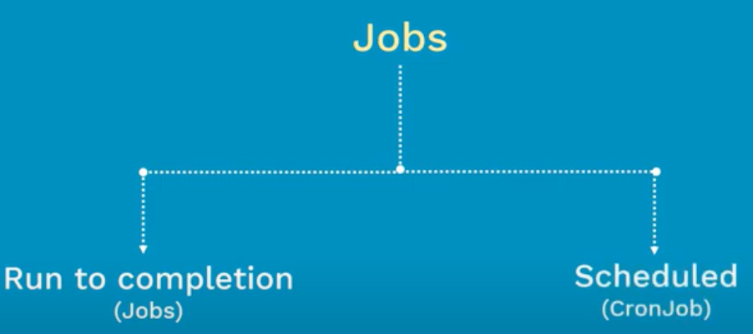

Run to completion:

It is primarily used to perform the batch processing

Once we apply this manifest file. It will execute the task. And once the task is complete. It will shut down.

Here, the controller will wait for the exit code 0

Kubernetes will not remove the pods here. It will be in shutdown state and those pods will not consume any resources.

When we delete the job, all the pods associated to the job will also be deleted.

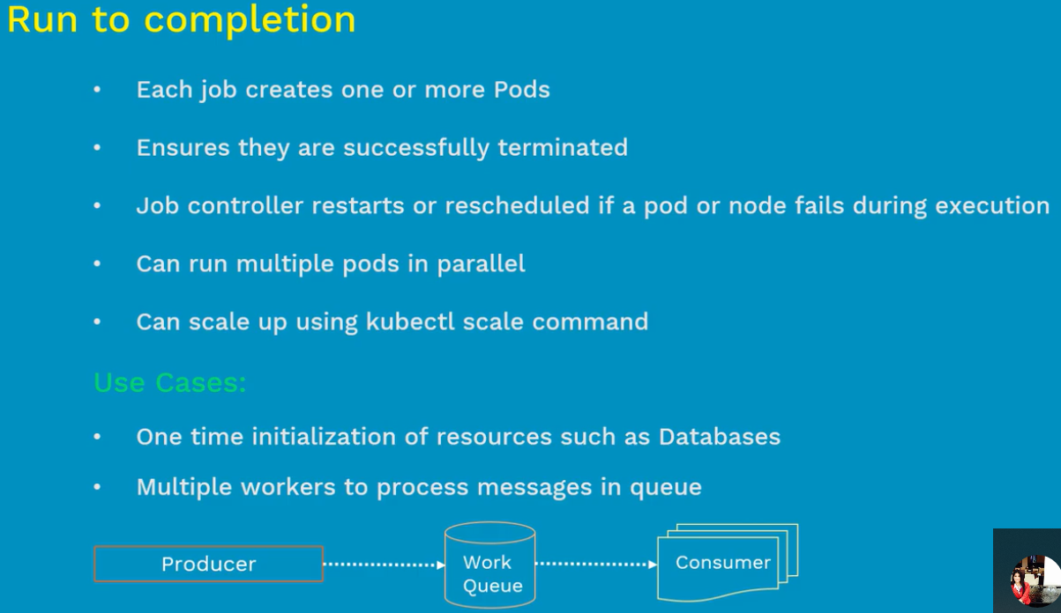

Scheduled/cron jobs:

Here, the task is to kick in at certain time and complete the task.

The purpose of this job is to basically perform the cleanup/free the disk space in scheduled time.

Manifest file:

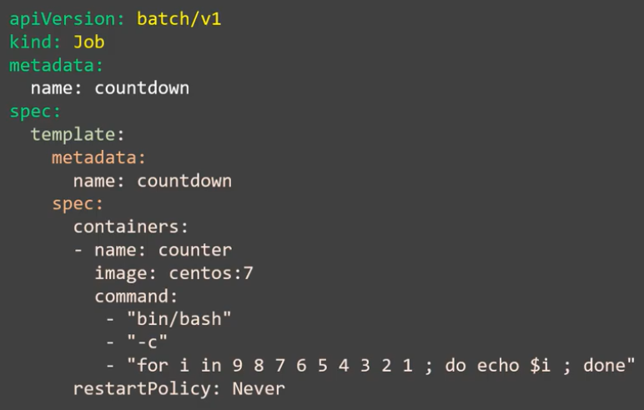

Display: